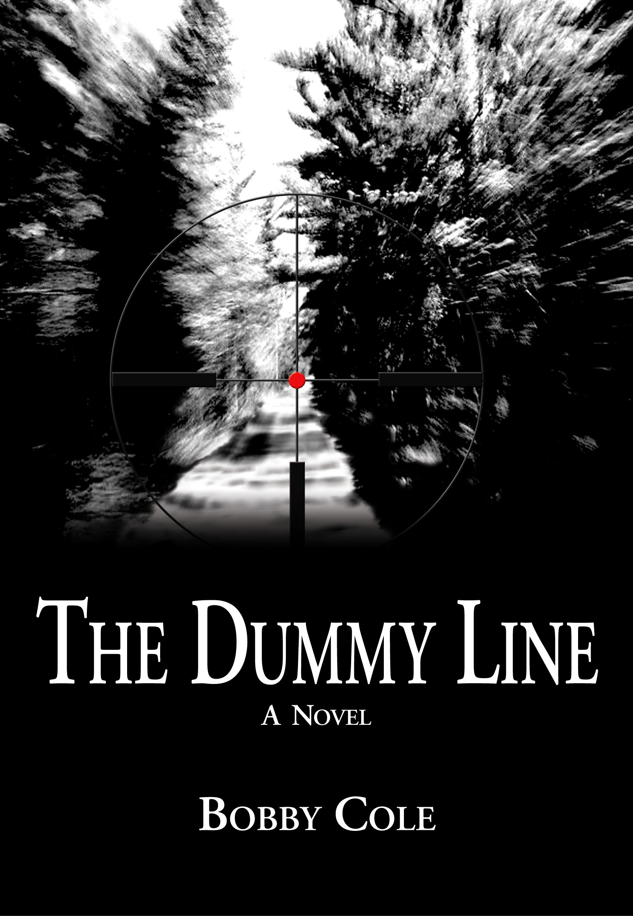
Mossy Oak® BioLogic® Executive Pens Thriller

MADISON, MS—8 January 2008—Bobby Cole, Mossy Oak® BioLogic® executive, has written The Dummy Line (Context Publishing Co., 19 Feb. 2008, $24.95), an action-packed suspenseful novel that will keep readers on the edges of their seats and quite possibility out of the woods at night.
Jake Crosby, a troubled stockbroker, has planned a weekend escape at his hunting camp with his nine-year-old daughter, Katy. In the middle of the night, a gang of redneck drug dealers attempts to break into the remote camp. The gang’s display of heinous intentions toward Jake and Katy causes Jake to make gut-wrenching decisions.
Running for their lives, Jake and Katy take the only escape route available which leads them deep into Alabama’s Noxubee River swamp. Crazed with blood lust and demanding immediate vengeance for their own, the frenzied gang anticipates Jake’s desperate moves as they stalk them throughout the night.
Jake’s choices put into motion a sequence of events that threatens everyone associated with him, and an unwitting young couple who happen to be in the wrong place at the worst possible time.
Randall Wallace, New York Times® Bestseller and writer-director-producer (Braveheart, Pearl Harbor, We Were Soldiers, Man in the Iron Mask) said, “Good novels grow out of a writer's rich imagination and love for his subject, and Bobby Cole shows both in The Dummy Line. A walk through the woods will never be the same again.”
Will Primos, founder of Primos® Hunting Calls, said “Wow! What a book! I couldn’t put it down. My heart raced as every emotion ran through me as the main character dealt with one crisis after another—situations we hope and pray we never encounter with our loved ones. This is definitely not a book for the tree stand. You won’t notice anything going on around you—including that big deer of a lifetime!”
Multiple #1 New York Times® Bestseller, Jill Conner Browne, says, “Bobby Cole weaves just the right amount of humor into a thrilling story that otherwise would be way too scary for me to read. The Dummy Line single-handedly eliminates the threat of hunting camps being taken over by women and children.”
Kyle Jennings, Context Publishing Company’s Publisher said, “Bobby Cole’s story deftly taps into the reader’s base fears and instincts while revealing the defining moments in one’s own character development. The Dummy Line is a fine piece of storytelling and I’m proud to be associated with it and Mr. Cole.”
Bobby Cole said, “Most of us that have been to a remote camp, hunting or fishing, probably have gotten a little spooked at night. The Dummy Line takes those emotions and twists them around a dangerous, worst-case scenario that could easily happen to any of us. Throw in the drama of having a young child involved and you’ve got a powerful story that grabs you. I had a ball writing it and I know that I’ll never leave my camp doors unlocked again!”
The Dummy Line is available at www.amazon.com, for personalized copies at www.readbobbycole.com, or directly from the publisher at www.contextpublishing.com.

About The Author
Bobby Cole, a Montgomery, Alabama, native, is Executive Vice President and COO of Mossy Oak® BioLogic®. He is an avid wildlife manager, hunter, and supporter of the Catch-A-Dream™ Foundation, who loves writing in his free time. Bobby lives with his wife and daughter in West Point, Mississippi.

About The Book
The Dummy Line
By Bobby Cole
Context Publishing Company, LLC.
Publication Date: February 19, 2008
Price: $24.95
ISBN 13: 978-0-9800171-0-6
ISBN 10: 0-9800171-0-6

For author and cover photo, please e-Mail: info@contextpublishing.com

